HANDOUT for Lesson 1: What to Teach with Video

Table 1. WHAT to teach: Potent Pedagogic Roles for Video
1. Facilitating COGNITION |  | 2. Providing realistic/amplified EXPERIENCES,  otherwise inaccessible
1 composite images e.g. split screen, highlighting, superimposition, green screen  2 animated diagrams exploring processes  3 visual representation / analogy / metaphor  4 illustrating concepts with real examples  5 modelling a situation or process by judicious simplification  6 juxtaposition of contrasting situations  7 condensing time by editing real life  8 narrative power through synchronous narration and pedagogic design |  | 1 movement with synchronous location sound  2 viewpoints e.g. aerial, undersea, extreme close-up  3 places e.g. dangerous / overseas locations  4 3D by good lighting & moving object or camera  5 slow / fast motion  6 people/animals interacting, real or drama  7 chronological sequence and pacing  8 resource material for viewers to analyse  9 one-off or rare events/resources  10 staged events e.g. dramatisation enactments, complex experiments

 | 3. Nurturing AFFECTIVE characteristics |  | 4. Demonstrating SKILLS
attitudes  emotions  feelings  activation  resolve  motivation | 1 galvanize / spur into action, provoke viewers to get up and do things  2 motivate a strategy by showing its success  3 stimulate appetite to learn, e.g. reveal the fascination of the subject  4 change attitudes/appreciations,  e.g. engender empathy  5 alleviate learner’s isolation  by showing / hearing the teacher or peers  6 reassure, encourage self-efficacy  7 authenticate academic abstractions by showing them solving real-life problems  8 create sense of importance, e.g. by using famous presenters |  | - manual/craft: making learning aids, cookery, joinery, painting, designing  - agility: dance, aerobics, gymnastics, athletics  - reasoning: problem solving, planning, brainstorming  - interpersonal: counselling, interviewing, teamwork, classroom teaching  - verbal: language proficiency, singing, recitation, authoring  - studying: researching information, collaborative learning, exam strategy  - technical: laboratory, mechanics, nursing

Notes regarding the four domains
The 33 roles are in fact TECHNIQUES and TEACHING FUNCTIONS that can powerfully enhance learning. That’s because they exploit video’s distinctive strengths, which other media do not possess.
The TECHNIQUES are distributed between the cognitive and experiential domains (1 and 2). The techniques in the Cognitive domain facilitate learning while those in the Experiential domain engender realism. Domains 3 and 4 both comprise teaching functions rather than techniques – Affective functions in Domain 3 and Skills functions in Domain 4.

Video’s presentational attributes
The basis of the learning-facilitation claim for the techniques and teaching functions in Table 1 is the rich symbol system of video – its presentational attributes, listed in Figure 1.
- moving images with synchronous narration and location sound
- real-time or slow motion
- real-life or diagrammatic
- real or dramatised behaviour (can include comparing styles of personal interaction)
- extreme close-ups
- chronological sequencing and pacing of sound and images
- visual metaphor
- specially constructed physical models to represent objects or concepts
- camera moves, zooms and framing
- customised lighting to ‘sculpture’ objects (hence bring out their three-dimensionality)
- shot transitions (including editing to condense time)
- composite images, e.g. split-screen, superimposition (including key-word screen-text)
- varying format (e.g. a segment in studio, then on location, interspersed with animation)
Figure 1. Video’s presentational attributes

Notes regarding each Domain
Domain 1. Cognition
Provided a video has been well designed pedagogically, the learning outcomes of the techniques and teaching functions in the Cognition domain of Table 1 are posited in Figure 2.
  - composite-image techniques can aid synthetic, analytic and discrimination skills; for substantiation of this claim see the various video clips illustrating these techniques.
  - animated diagrams – for explaining dynamic processes: they help students to share the teacher's imagery; particularly powerful is interspersing real life with animation of obscured motion, e.g. the motion of the diaphragm of a person with breathing difficulties.
  - visual metaphor/analogy/representation – to concretise complex/abstract processes
  - illustrating abstract concepts with evocative real-world examples, hence making the concepts more concrete. (Note the overlap with domain 2 - the presentation of real-world examples would entail experiential techniques, such as staging events or visits to dangerous locations. However, domain 2 is what we show, whereas 1.4 is a why we show it (a teaching function)
  - modelling a process or situation with a tailored, simplified version – which scaffolds learning by showing only the pertinent features. (Like 1.4, this is another teaching function.)
  - juxtaposition in quick succession, of contrasting situations/processes – to aid discrimination
  - condensing time by pruning real-world processes (e.g. editing out non-salient events) thus bringing the duration within the viewer's concentration span
  - narrative power – narrative creates coherence and aids recall through its network of causal links and signposting (Laurillard et al, 2000). Additional respects in which narrative facilitates learning are discussed in Koumi (2006, Chapters 5 and 6).
Figure 2. Learning anticipated through the techniques in Domain 1 of Table 1 (Cognition)

An illustration of cognitive role 1.5 modelling a situation with judicious simplification is illustrated in Unit 3 by comparing the text-book diagram of relationships between disciplines and phenomena with the video diagram
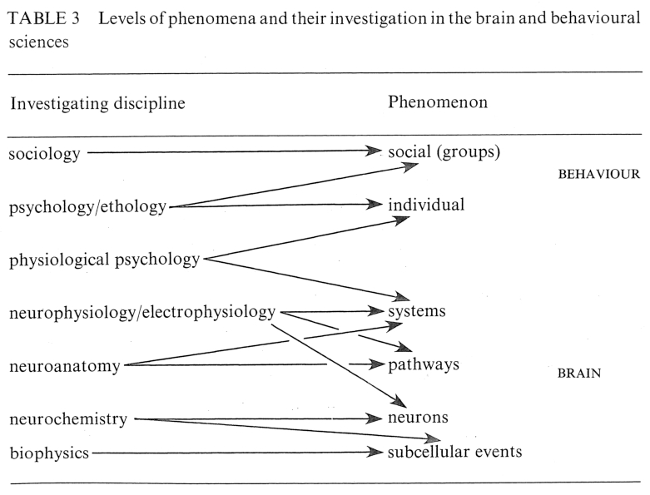
Figure 3. Text-book version: Levels of phenomena and their investigation

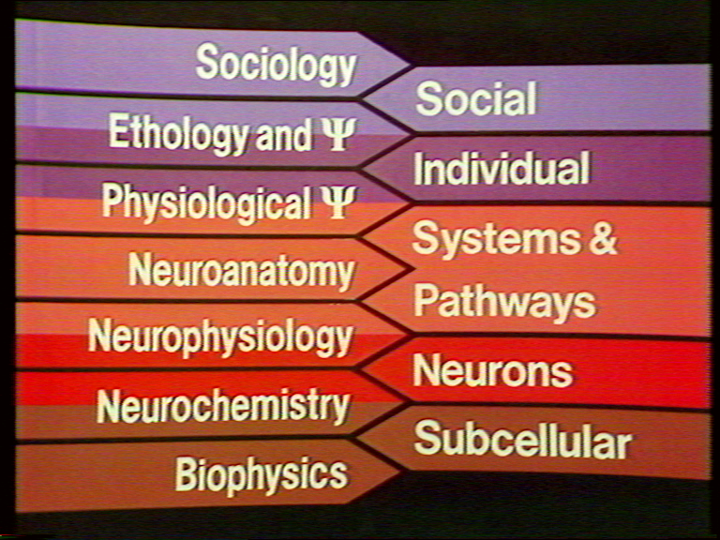
Figure 4. Simplification of the relationships, as shown on the video

The simplifications, compared to Figure 3, are as follows.
- the word psychology is replaced by the Greek letter ψ
- the discipline of electrophysiology has been omitted in Figure 4.
- systems and pathways in Figure 3 are combined in one band on the right of Figure 4. So the discipline of physiological psychology is shown related both to systems and to pathways, instead of just to systems.
- the words BEHAVIOUR and BRAIN are omitted on the right of Figure 4

As explained in the video, such simplifications can be justified on two counts:-
- the spoken words can augment the simplified graphics and hence recover some of the complications (I noted some examples earlier).
- TV is not the appropriate medium to deal with minute details – because these require concentrated study at the individual student's own pace (better done by reading text)

Domain 2. Experiential
The Experiential domain is crucial for the other three.
In the Cognitive domain, apart from some abstract subjects like Logic and Pure Mathematics, learning is largely concerned with knowledge about the real world, therefore when learners experience the real world (vicariously but realistically) their study is grounded in context. Consequently, instructional video is often used to transport learners into the real world.
Those argument concerning cognitive learning, apply even more so to skills learning – all the roles of Domain 4 (Skills) depict real life experiences. Admittedly, many vicarious video experiences of skills demonstrations need to be followed up by real life practice, but the video depiction would provide valuable grounding.
The same is true for all the Affective roles – they all depict real life experiences and behaviour. For example, changing attitudes towards people might involve seeing various contrasts in situ, like peoples’ socialising behaviour (Bates, 1984, p. 246).
The strength of all these influences is mediated by how realistic are the vicarious experiences.

Domain 3. Nurturing Affective Characteristics
The principal intention of the eight teaching functions in the Affective domain of Table 1 is to engender sustained affective changes in students, lasting into the future (Koumi, 2015 p.5-6).

Note for Domain 4, you can think of each skill as the ability to handle different things:

4. Demonstrating SKILLS | In order to handle
- manual/craft: making learning aids, cookery, joinery, painting, designing | craft tools, materials
- agility: dance, aerobics, gymnastics, athletics | body movements
- reasoning: problem solving, planning, brainstorming | symbols, techniques
- interpersonal: counselling, interviewing, teamwork, classroom teaching | people
- verbal: language proficiency, singing, recitation, authoring | vocalization
- studying: researching information, collaborative learning, exam strategy | learning
- technical: laboratory, mechanics, nursing | technical equipment
Figure 5. Skills enable handling different things

References
Bates, A. W. (1984). Broadcasting in Education, Constable, London.
Koumi, J (2015) Potent Pedagogic roles for Video (33 roles)
https://www.academia.edu/8092450/Potent_Pedagogic_Roles_for_Video_33_roles_
Koumi, J (2006, reprinted 2009). Designing video and multimedia for open and flexible learning , RoutledgeFalmer, London and New York.
Laurillard, D.M., Stratford, M., Luckin, R., Plowman, L. and Taylor, J. (2000). ‘Affordances for learning in a non-linear narrative medium’, Journal of Interactive Media in Education, 2000(2). http://www-jime.open.ac.uk/article/2000-2/50.html

